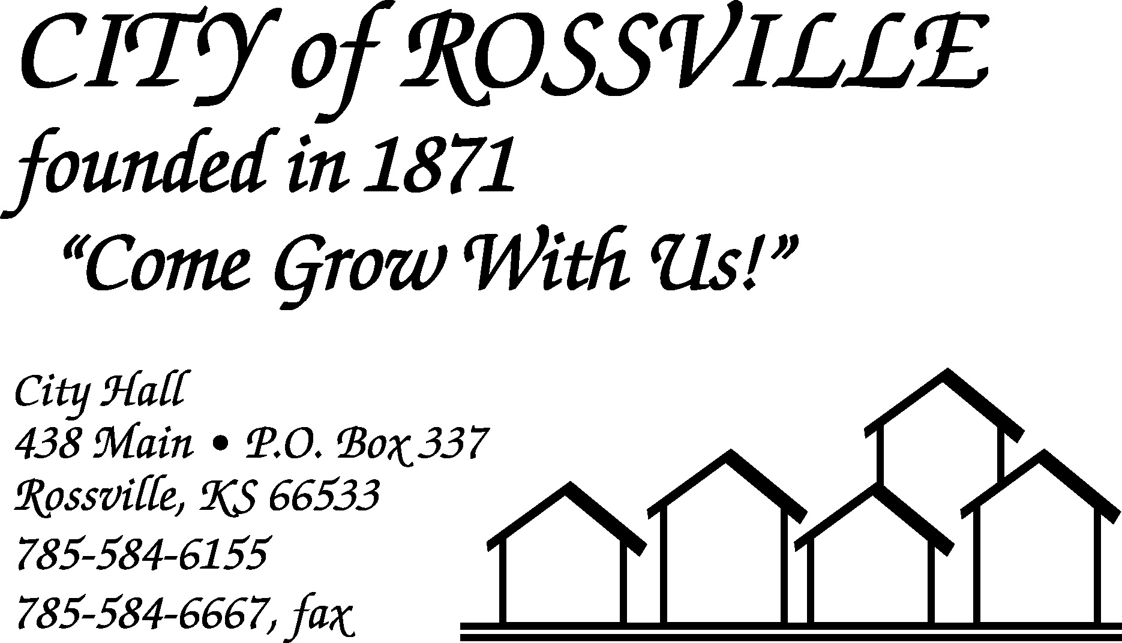

City Hall January 19, 2021

Due to the holiday on Monday the Rossville City Council meeting was called to order on Tuesday, January 19, 2021 at 7:01 pm by Mayor Kenneth Wichman using online Zoom meeting.

Council members present via Zoom were Trish Heim, Dan Glotzbach, Christi McKenzie, James Meyer and Toby McCullough.

Also present via Zoom was Tracey Taylor.

Motion by Dan Glotzbach to approve minutes of the January 4, 2021 meeting as corrected was seconded by Trish Heim and carried.

The following bills were presented;
Alan Zlatnik $1,588.95 Lisa Stum $1,226.78
Tracey Taylor 887.99 Michael Kirk 1,183.52
Bowe Behymer 504.54 Douglas Schreiner 187.85
Trent Stanley 1,094.93 Jacob Akin 262.45
Jason Connell 1,098.73 Kerry Dick 385.05
Tina Dick 445.39 Randall Anderson 723.51
EFTPS-Fed Wh 1,068.27 EFTPS-FICA 2,278.40
EMPower Retirement 135.00 Grace Hier 60.00
Kansas Payment Center 247.46 Kansas Withholding Tax 524.69
KP & F 1,050.40 KPERS 1,385.63
A T & T -First Net 473.39 AFLAC 634.88
Amazon.com 43.37 Casey’s Business Mastercard 383.32
Century Business Tech. 595.07 Ks Employment Security Fund 97.21
Sam’s Club 575.24 Shawnee Co Solid Waste Dept 255.00
US Bank 189.92 U.S. Post Office 1.40
Aramark 221.85 BG Consultants, Inc. 538.00
Blue Cross Blue Shield of Ks 10,114.85 CenturyLink Business Service 564.20
Continental Research Corp. 261.85 Core & Main LP 841.42
Evergy 2,162.84 Gerald Wilhelm 75.88
Haag, Inc. 718.31 Hamm, Inc. 195.37
Heinen Repair Service, Inc. 12,668.09 Kansas One-Call System, Inc. 10.80
KMJA 25.00 Kristina Moore 76.07
Ks Dept of Health & Environ 72.00 Menards 178.45
Pace Analytical Services, LLC 300.00 Rossville Auto Supply 143.26
Rossville Water Supply 216.81 Schulte Supply Inc. 162.29
Shawnee Co. Solid Waste 6,885.20 Stanley Oyler Law Offices 1,070.00
Tarwater Farm & Home Supply 46.10 Universal Chemical LLC 344.28
US Bank Equipment Finance 16,861.79 Wehner’s Thriftway 149.32
Evergy 1,761.49
TOTAL 76,253.86

Motion by Christi McKenzie to pay bills as presented totaling $76,253.86 was seconded by Dan Glotzbach and carried.

Motion by Trish Heim to approve agenda as written was seconded by James Meyer and carried.

Council reviewed end of year finance report.

Alan Zlatnik logged onto meeting at 7:06pm.

Jason Connell logged onto meeting at 7:10pm.

Mayor reported that Beyond Baseball had contacted him about proposed changes/improvements to Campbell field/stadium for the 2021 season. Mayor presented copy of the 2021 schedule and noted that the Topeka Golden Giants will be playing home games in Rossville in 2021. Schedule to be forwarded to other groups that use the field.

Utility Superintendent Alan Zlatnik had no items to report.

Police Chief Jason Connell reported on COVID vaccinations for officers and discussed budget issues with council.

Motion by Trish Heim to adjourn was seconded by Dan Glotzbach and carried. Meeting adjourned at 7:34pm.

Lisa M. Stum
City Clerk

